
The art of measuring the moisture content of air is termed “Psychrometry”.
The science which investigates the thermal properties of moist air, considers the measurement and control of the moisture content of air, and studies the effect of atmospheric moisture on material and human comfort may properly be termed “Psychrometrics’’.
1. Dry air:The term ‘dry air’ is used to indicate the water free contents of air.
2. Saturated air :Moist air is said to be saturated when its condition is such that it can
co-exist in natural equilibrium with an associated condensed moisture phase presenting a flat
surface to it.
3. Dry-bulb temperature (DBT):It is the temperature of air as registered by an ordinary
thermometer(t_{db}).
4. Wet-bulb temperature (WBT):It is the temperature registered by a thermometer
when the bulb is covered by a wetted wick and is exposed to a current of rapidly moving air (t_{wb}).
5. Adiabatic saturation temperature:It is the temperature at which the water or ice
can saturate air by evaporating adiabatically into it. It is numerically equivalent to the measured
wet bulb temperature (as corrected, if necessary for radiation and conduction) (t_{wb}).
6. Wet bulb depression:It is the difference between dry-bulb and wet bulb temperatures(t_{db} – t_{wb}).
7. Dew point temperature (DPT):It is the temperature to which air must be cooled at
constant pressure in order to cause condensation of any of its water vapour. It is equal to steam
table saturation temperature corresponding to the actual partial pressure of water vapour in the
air (t_{dp}).
8. Dew point depression:It is the difference between the dry bulb and dew point
temperatures(t_{db} – t_{dp}).
9. Specific humidity (Humidity ratio):It is the ratio of the mass of water vapour per
unit mass of dry air in the mixture of vapour and air, it is generally expressed as grams of water
per kg of dry air. For a given barometric pressure it is a function of dew point temperature alone.
10. Relative humidity (RH): It is the ratio of the partial pressure of water vapour in
the mixture to the saturated partial pressure at the dry bulb temperature, expressed as percentage.
11. Sensible heat:It is the heat that changes the temperature of a substance when added
to or abstracted from it.
12.Latent heat:It is the heat that does not affect the temperature but changes the state
of substance when added to or abstracted from it.
13. Enthalpy: It is the combination energy which represents the sum of internal and flow
energy in a steady flow process. It is determined from an arbitrary datum point for the air mixture
and is expressed as kJ per kg of dry air (h).
Note. When air is saturated DBT, WBT, DPT are equal.
PSYCHROMETERS
A psychrometer is a device which is used for measuring dry bulb and wet bulb temperatures
simultaneously.
The psychrometers may be classified as follows:
1. Laboratory psychrometer 2. Sling psychrometer
3. Aspirating psychrometer 4. Continuous recording psychrometer.
Slingpsychrometer
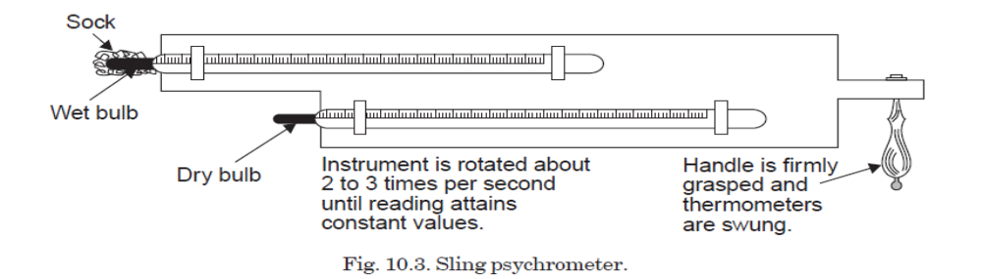
The sling psychrometer consists of two thermometers mounted on a baseplate. The one with the ‘sock’ is wet-bulb thermometer , the other is dry-bulb. The wet bulb existsbelow the dry-bulb. This is done purposely so that ‘sock’ can be dipped in water without wetting thedry-bulb. The handle of the frame helps for rotating the psychrometer to produce necessary airmotion. As the psychrometer is rotated it provides necessary air velocity over the thermometer.Fast movement of air past the ‘sock’ is necessary to bring the air at temperature t_{db}always inimmediate contact with the wet ‘sock’. The temperature spread between dry bulb and wet bulbreadings depends upon the amount of moisture in the air. Dry air, or air that has low moisturecontent has a low wet bulb temperature ; humid air that has a high moisture content, has a highwet-bulb temperature.

Adiabatic saturation process
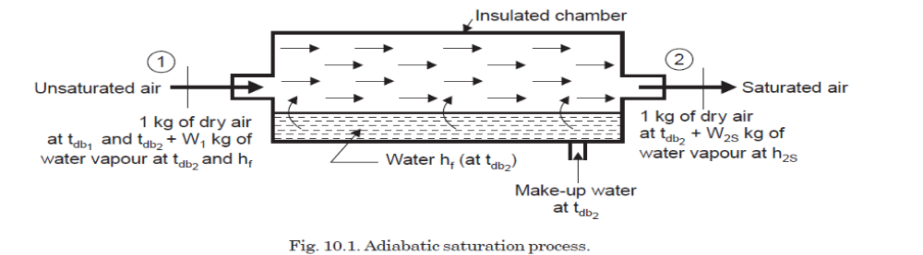
In an insulated chamber when unsaturated air flows over a long sheet of water the water evaporates, and the specific humidity of the air increases. As the evaporation takes place both the air and water are cooled. The process continues until the energy transferred from the airto the water is equal to the energy required to vapourise the water. When this point is reached, thermal equilibrium exists with respect to water, air and water vapour, and consequently the air is saturated. The equilibrium temperature is called the adiabatic saturation temperature orthe thermodynamic wet bulb temperature. The make-up water is introduced at this temperature to make the water level constant.

PSYCHROMETRIC PROCESSES
The processes affecting the psychrometric properties of air are called psychrometric processes.
The important psychrometric processes are enumerated and explained in the following text :
1. Mixing of air streams 2. Sensible heating
3. Sensible cooling 4. Cooling and dehumidification
5. Cooling and humidification 6. Heating and dehumidification
7. Heating and humidification.
Mixing of air streams
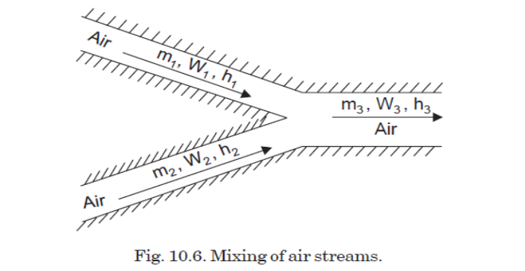
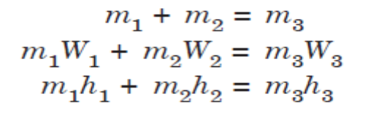

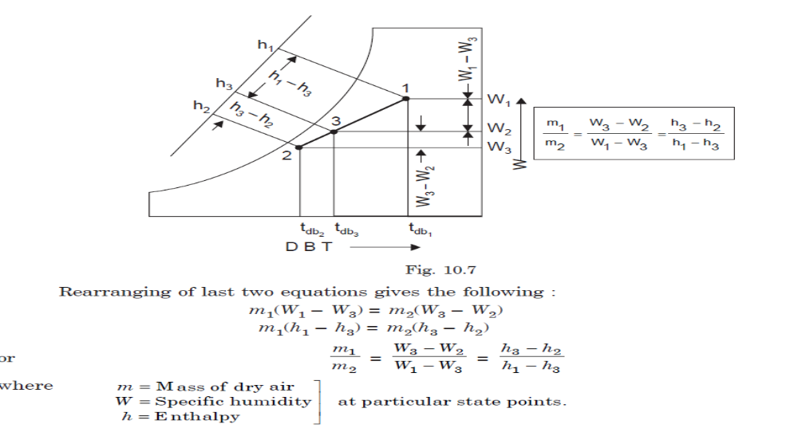
Mixing of several air streams is the process which is very frequentlyused in air conditioning. This mixing normally takes place without the addition or rejection ofeither heat or moisture, i.e., adiabatically and at constant total moisture content. On the psychrometric chart, the specific humidity and enthalpy scales are linear, ignoringenthalpy deviations. Therefore, the final state 3 lies on a straight line connecting the initial statesof the two streams before mixing, and the final state 3 divides this line into two parts that are inthe same ratio as were the two masses of air before mixing.
Sensible Heating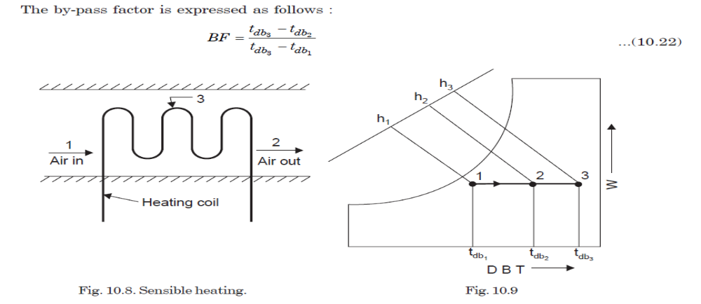

When air passes over a dry surface which is at a temperature greater than its (air) dry bulb
temperature, it undergoes sensible heating. Thus the heating can be achieved by passing the air
over heating coil like electric resistance heating coils or steam coils. During such a process, the
specifichumidity remains constant but the dry bulb temperature rises and approaches that of the
surface. The extent to which it approaches the mean effective surface temperature of the coil is
conveniently expressed in terms of the equivalent by-pass factor.
The by-pass factor (BF) for the process is defined as the ratio of the difference between the
mean surface temperature of the coil and leaving air temperature to the difference between the
mean surface temperature and the entering air temperature. Thus air at temperature
t_{db1}, passes over a heating coil with an average surface temperature t_{db3}and leaves at temperature
t_{db2}.In a complete air conditioning system the preheating and reheating of air are among the familiar examples of sensible heating.
Sensible Cooling
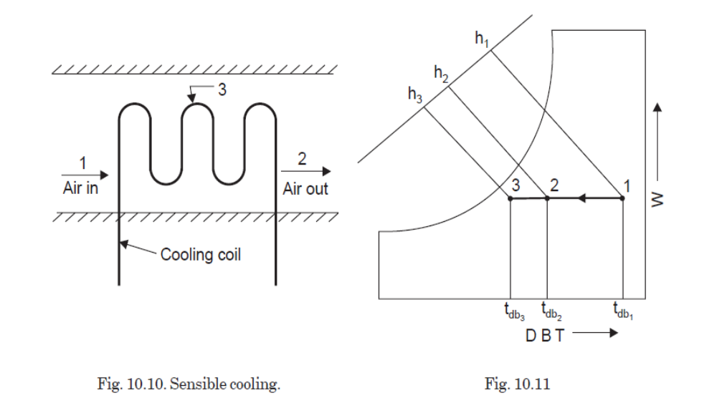
Air undergoes sensible cooling whenever it passes over a surface that is at
a temperature less than the dry bulb temperature of the air but greater than the dew point
temperature. Thus sensible cooling can be achieved by passing the air over cooling coil like
evaporatingcoil of the refrigeration cycle or secondary brine coil. During the process, the specific
humidity remains constant and dry bulb temperature decreases, approaching the mean effective
surface temperature. On a psychrometric chart the process will appear as a horizonal line 1–2
where point 3 represents the effective surface temperature. For this process :
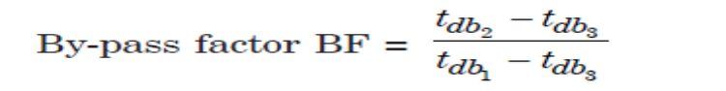

Cooling and Dehumidification
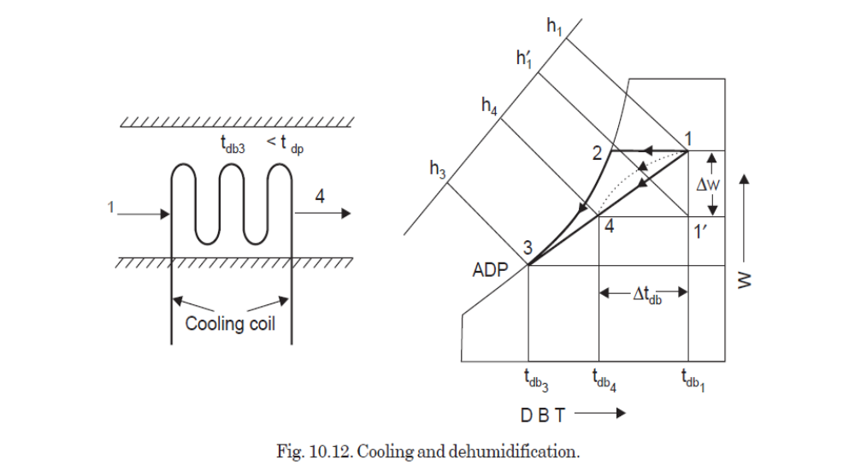
Whenever air is made to pass over a surface or through a spray of water.that is at a temperature less than the dew point temperature of the air, condensation of some ofthe water vapour in air will occur simultaneously with the sensible cooling process. Any air thatcomes into sufficient contact with the cooling surface will be reduced in temperature to the meansurface temperature along a path such as 1-2-3 with condensation and thereforedehumidification occurring between points 2 and 3. The air that does not contact the surface willbe finally cooled by mixing with the portion that did, and the final state point will somewhere onthe straight line connecting points 1 and 3. The actual path of air during the path will not bestraight line shown but will be something similarly to the curved dashed line 1–4.
The final state point of air passing through a cooling and dehumidifyingapparatus is in effect a mixture condition that results from mixing the fraction of the air,which is equal to the equivalent by-pass factor (BF) and is at initial state point and the remainingfraction which is equal to one minus by pass factor (1–BF) and is saturated at the apparatus dew
Point.
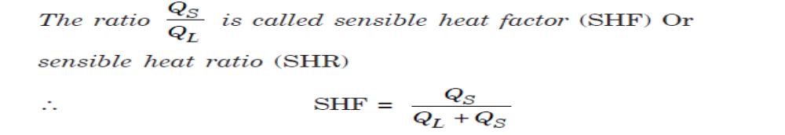

Cooling and Humidification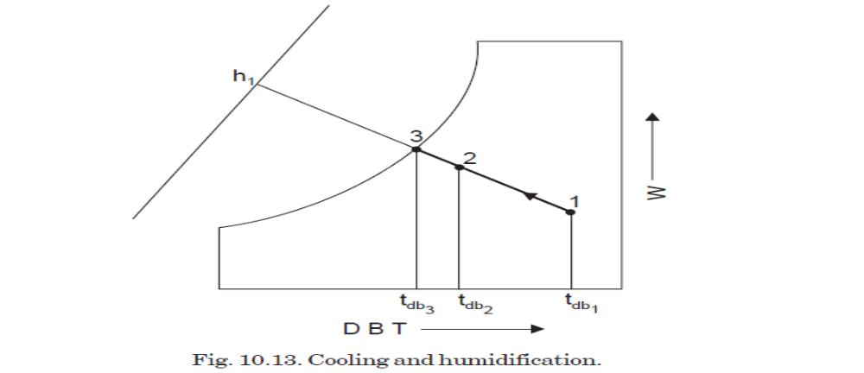
If unsaturated air is passed through a spray of continuously recirculated water, the specific
humidity will increase while the dry bulb temperature decreases. This is the process of adiabatic
saturationorevaporative cooling. This process is one of constant adiabatic-saturation temperature
and for all practical purposes, one of constant wet bulb temperature. The process is
illustrated as path 1-2 on Fig., with wet bulb temperature of air being that of point 3, which
is also equilibrium temperature of the recirculated water if there is sufficient contact between air
and spray, the air will leave at a condition very close to that of point 3. The concept of equivalent by
pass can be applied to this process but another term is more used to describe the performance of a
humidifying apparatus. It is the ‘saturating’ or ‘humidifying efficiency’ which is defined as theratio of dry-bulb temperature decrease to the entering wet bulb depression usually expressed aspercentage. Thus, from Fig. the saturating efficiency is :
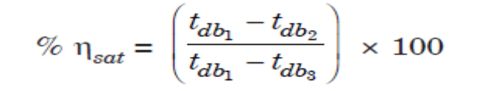
Heating and Dehumidification
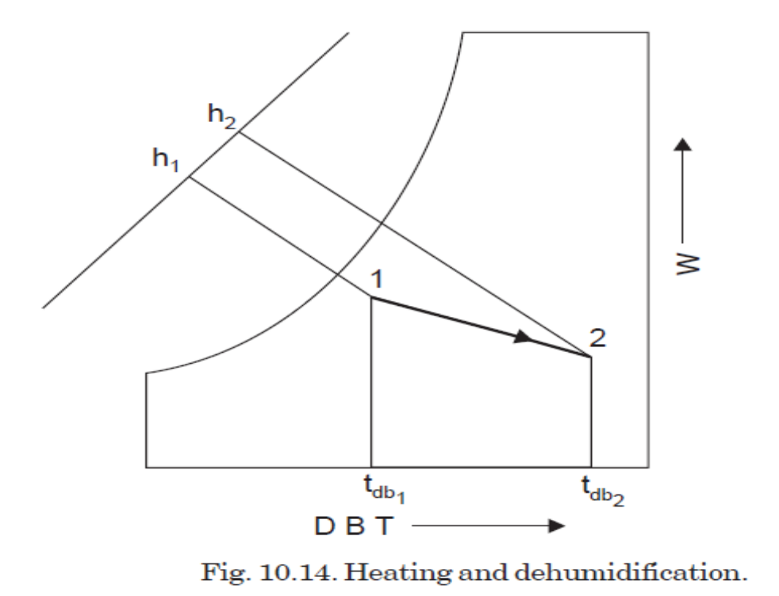
If air is passed over a solid absorbent surface or through a liquid absorbent spray simultaneous
heating and dehumidification is accompanied. In either case the dehumidification results
from adsorbent or absorbent having a lower water vapour pressure than air. Moisture is condensed
out of the air, and consequently the latent heat of condensation is liberated, causing sensible
heating of air. If these were the only energies involved, the process would be the inverse of the
adiabatic saturation process. There is, however, an additional energy absorbed or liberated by the
active material, termed the heat of adsorption or absorption. For the solid adsorbents used commercially,such as silica gel or activated alumina, and for the more common liquid absorbents,such as solutions of organic salts or inorganic compounds like ethylene, glycol, heat is involved andresults in additional sensible heating. Thus the path lies above a constant wet bulb line on thepsychrometric chart such as path 1-2 in Fig. .

Heating and Humidification
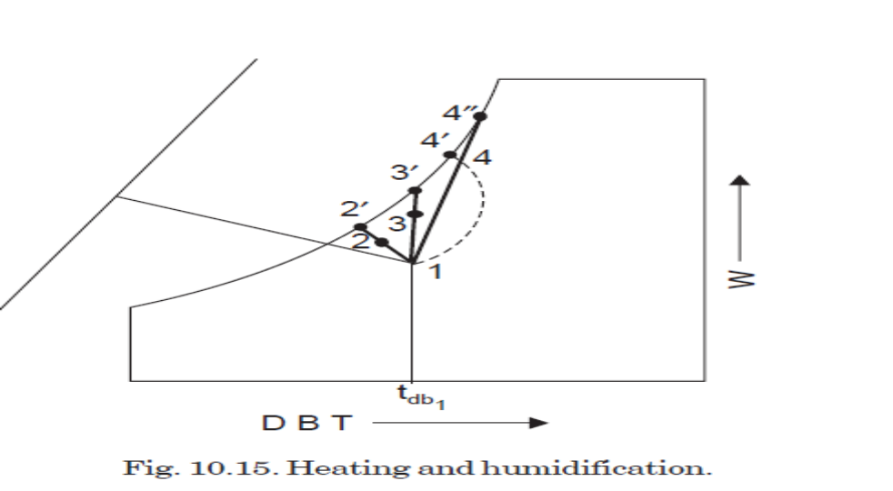
If air is passed through a humidifier which has heated water sprays instead of simply
recirculated spray, the air is humidified and may be heated, cooled or unchanged in temperature.
In such a process the air increases in specific humidity and the enthalpy, and the dry bulb temperature
will increase or decrease according to the initial temperature of the air and that of the
spray. If sufficient water is supplied relative to the mass flow of air, the air will approach saturation
at water temperature. Examples of such processes are shown on Fig.
Process 1-2 :It denotes the cases in which the temperature of the heated spray wateris less than the air DBT.
Process 1-3 :It denotes the cases in which the temperature is equal to the air DBT.
Process 1-4 :It denotes the cases in which a spray temperature is greater than air DBT and this is the process ofHeating and Humidification,

Electro lux refrigerator
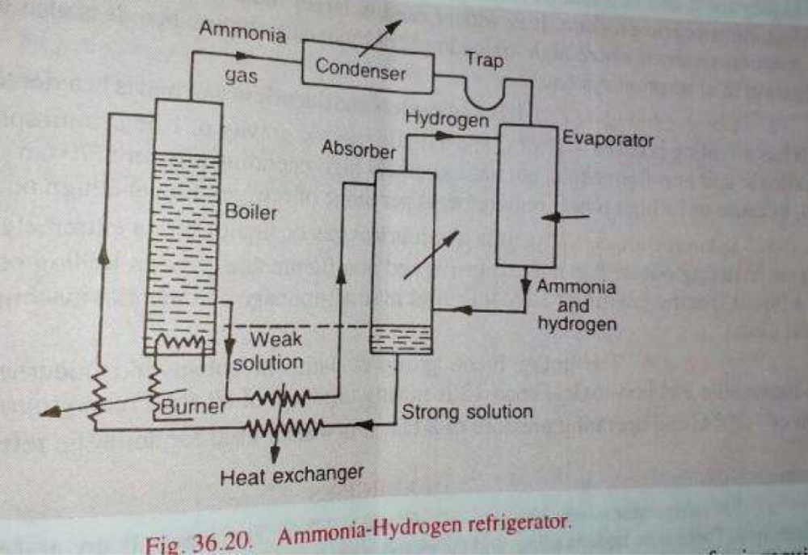
Electrolux refrigerator working on the ammonia absorption process, the pump may be omitted by the induction of hydrogen into the low pressure side. The ammonia acts, normally under its partial pressure. The total pressure is arranged to be practically uniform throughout the system. Thus weak solution, passing from the boiler to the absorber, moves under gravity. The flow of strong solution, in the opposite direction, is assisted by a vertical pipe between the boiler and absorber, which is heated at its lower end by a small heating coil or gas jet. The chief advantage of Electrolux refrigerator is no requirement of compressor or pump. There is no noise due to moving parts and no machinery to give mechanical trouble. The coefficient of performance of Electrolux refrigerator is ratio of heat absorbed by evaporator to heat supplied by burner

Refrigerants
A ‘refrigerant’ is defined as any substance that absorbs heat through expansion or vaporization and loses it through condensation in a refrigeration system.
Examples :Air, ammonia (NH3), Carbon dioxide(CO2), Sulphur dioxide (SO2)
1.Primary refrigerants are those working mediums or heat carriers which directly take part in the refrigeration system and cool the substance by the absorption of latent heat
e.g.Ammonia, Carbon dioxide, Sulphur dioxide, Methyl chloride, Methylene chloride, Ethyl chloride and Freon group etc.
2. Secondary refrigerants are those circulating substances which are first cooled withthe help of the primary refrigerants and are then employed for cooling purposes,e.g. ice, solid carbon dioxide etc. These refrigerants cool substances by absorption of their sensible heat.
Desirable properties of an ideal refrigerant
An ideal refrigerant should possess the following properties :
1. Thermodynamic properties :
(i) Low boiling point
(ii) Low freezing point
(iii) Positive pressures (but not very high) in condenser and evaporator.
(iv) High saturation temperature
(v) High latent heat of vaporization.
2. Chemical Properties :
(i) Non-toxicity
(ii) Non-flammable and non-explosive
(iii) Non-corrosiveness
(iv) Chemical stability in reacting
(v) No effect on the quality of stored (food and other) products like flowers, with other materials i.e., furs and fabrics.
(vi) Non-irritating and odourless.
3. Physical Properties :
(i) Low specific volume of vapour
(ii) Low specific heat
(iii) High thermal conductivity
(iv) Low viscosity
(v) High electrical insulation.

4. Other Properties :
(i) Ease of leakage location
(ii) Availability and low cost
(iii) Ease of handling
(iv) High C.O.P.
(v) Low power consumption per tonne of refrigeration.
(vi) Low pressure ratio and pressure difference.

Air
Properties :
(i) No cost involved ; easily available.
(ii) Completely non-toxic.
(iii) Completely safe.
(iv) The C.O.P. of air cycle operating between temperatures of 80°C and – 15°C is 1.67.
Uses :
(i) Air is one of the earliest refrigerants and was widely used even as late as World War I wherever a completely non-toxic medium was needed.
(ii) Because of low C.O.P., it is used only where operating efficiency is secondary as in aircraft refrigeration.

Ammonia (NH3)
Properties :
(i) It is highly toxic and flammable.
(ii) It has the excellent thermal properties.
(iii) It has the highest refrigerating effect per kg of refrigerant.
(iv) Low volumetric displacement.
(v) Low cost.
(vi) Low weight of liquid circulated per tonne of refrigeration.
(vii) High efficiency.
(viii) The evaporator and condenser pressures are 3.5 bar abs. and 13 bar abs. (app.) respectively
at standard conditions of – 15°C and 30°C.
Uses :
(i) It is widely used in large industrial and commercial reciprocating compression systems
where high toxicity is secondary.
It is extensively used in ice plants, packing plants, large cold storages and skating rinksetc.
(ii) It is widely used as the refrigerant in absorption systems.

Sulphur dioxide (SO2)
Properties :
(i) It is a colourless gas or liquid.
(ii) It is extremely toxic and has a pungent irritating odour.
(iii) It is non-explosive and non-flammable.
(iv) It has a liquid specific gravity of 1.36.
(v) Works at low pressures.
(vi) Possesses small latent heat of vapourisation.
Uses :
It finds little use these days. However its use was made in small machines in early days.

Carbon dioxide (CO2)
Properties :
(i) It is a colourless and odourless gas, and is heavier than air.
(ii) It has liquid specific gravity of 1.56.
(iii) It is non-toxic and non-flammable.
(iv) It is non-explosive and non-corrosive.
(v) It has extremely high operating pressures.
(vi) It gives very low refrigerating effect.
Uses :
This refrigerant has received only limited use because of the high power requirements per
tonne of refrigeration and the high operating pressures. In former years it was selected for marine
refrigeration, for theater air-conditioning systems, and for hotel and institutional refrigeration
instead of ammonia because it is non-toxic.
At the present-time its use is limited primarily to the manufacture of dry ice (solid carbon
dioxide).

R-12 (Dichloro-difluoro methane) or Freon-12
Properties :
(i) It is non-toxic, non-flammable, and non-explosive, therefore it is most suitable refrigerant.
(ii) It is fully oil miscible therefore it simplifies the problem of oil return.
(iii) The operating pressures of R-12 in evaporator and condenser under standard tonne of
refrigeration are 1.9 bar abs. and 7.6 bar abs. (app.).
(iv) Its latent heat at – 15°C is 161.6 kJ/kg.
(v) C.O.P. = 4.61.
(vi) It does not break even under the extreme operating conditions.
(vii) It condenses at moderate pressure and under atmospheric conditions.
Uses :
1. It is suitable for high, medium and low temperature applications.
2. It is used for domestic applications.
3. It is excellent electric insulator therefore it is universally used in sealed type compressors.

R-22 (Monochloro-difluoro methane) or Freon-22
R-22 refrigerant is superior to R-12 in many respects. It has the following properties and uses :
Properties :
(i) The compressor displacement per tonne of refrigeration with R-22 is 60% less than the
compressor displacement with R-12 as refrigerant.
(ii) R-22 is miscible with oil at condenser temperature but tries to separate at evaporator temperature when the system is used for very low temperature applications (– 90°C). Oil separators must be incorporated to return the oil from the evaporator when the system is used for such low temperature applications.
(iii) The pressures in the evaporator and condenser at standard tonne of refrigeration are 2.9 bar abs. and 11.9 bar abs.
(iv) The latent heat at – 15°C is low and is 89 kJ/kg.
Uses :
R-22 is universally used in commercial and industrial low temperature systems.

