2/4 B.E.( EEE ) 2006 ADMITTED BATCH ONWARDS

SCHEME OF INSTRUCTIONS

SECOND YEAR

FIRST SEMESTER

CODE | SUBJECT | INSTRUCTION  Periods per  Week | UNIVERSITY  EXAMINATION |  | SESSIONAL  MARKS | TOTAL  MARKS | Credits
CODE | SUBJECT | INSTRUCTION  Periods per  Week | DURATION  (HOURS) | MARKS | SESSIONAL  MARKS | TOTAL  MARKS | Credits
EEE211 | MATHEMATICS-III  (Common with ECE) | 4 | 3 | 70 | 30 | 100 | 4
EEE212 | ENGG. MECHANICS &STRENGTH OF MATERIALS  (Common with ECE & Met. Engg.) | 5 | 3 | 70 | 30 | 100 | 4
EEE213 | NETWORK THEORY  (Common with ECE) | 4 | 3 | 70 | 30 | 100 | 4
EEE214 | ELECTROMAGNETICS | 4 | 3 | 70 | 30 | 100 | 4
EEE215 | ELECTRONIC DEVICES &CIRCUITS  (Common with ECE) | 4 | 3 | 70 | 30 | 100 | 4
EEE216 | Electrical Measurements | 4 | 3 | 70 | 30 | 100 | 4
EEE217 | NETWORKS & MEASUREMENTS LABORATORY | 3 | 3 | 50 | 50 | 100 | 2
EEE218 | ELECTRONIC DEVICES& CIRCUITS  LABORATORY | 3 | 3 | 50 | 50 | 100 | 2
 | TOTAL | 31 |  | 520 | 280 | 800 | 28

2/4 B.E.( EEE ) 2006 ADMITTED BATCH ONWARDS

SCHEME OF INSTRUCTIONS

SECOND YEAR

SECOND SEMESTER

CODE | SUBJECT | INSTRUCTION  Periods per  Week |  | UNIVERSITY  EXAMINATION |  |  | SESSIONAL  MARKS | TOTAL  MARKS | Credits
CODE | SUBJECT |  |  | DURATION  (HOURS) | MARKS |  | SESSIONAL  MARKS | TOTAL  MARKS | Credits
EEE221 | MATHEMATICS-IV  (Common with ECE) | 4 | 3 |  |  | 70 | 30 | 100 | 4
EEE222 | PERFORMANCE AND DESIGN OF  ELECTRICAL MACHINES - I | 4 | 3 |  |  | 70 | 30 | 100 | 4
EEE223 | ANALOG ELECTRONIC CIRCUITS  (Common with ECE) | 4 | 3 |  |  | 70 | 30 | 100 | 4
EEE224 | THERMAL PRIME MOVERS | 5 | 3 |  |  | 70 | 30 | 100 | 4
EEE225 | SIGNALS & SYSTEMS  (Common with ECE) | 4 | 3 |  |  | 70 | 30 | 100 | 4
EEE226 | ENVIRONMENTAL SCIENCE | 4 | 3 |  |  | 70 | 30 | 100 | 2
EEE227 | THERMAL PRIME MOVERS  LABORATORY | 3 | 3 |  |  | 50 | 50 | 100 | 2
EEE228 | ANALOG ELECTRONIC CIRCUITS  LABORATORY | 3 | 3 |  |  | 50 | 50 | 100 | 2
 | TOTAL | 31 |  |  |  | 520 | 280 | 800 | 26

3/4 B.E.( EEE ) 2006 ADMITTED BATCH ONWARDS

SCHEME OF INSTRUCTIONS

THIRD YEAR

FIRST SEMESTER

CODE | SUBJECT | INSTRUCTION  Periods per  Week | UNIVERSITY  EXAMINATION |  | SESSIONAL  MARKS | TOTAL  MARKS | Credits
CODE | SUBJECT | INSTRUCTION  Periods per  Week | DURATION  (HOURS) | MARKS | SESSIONAL  MARKS | TOTAL  MARKS | Credits
EEE311 | PULSE & DIGITAL CIRCUITS  (Common with ECE) | 4 | 3 | 70 | 30 | 100 | 4
EEE312 | LINEAR I.C.s & APPLICATIONS  (Common with ECE) | 4 | 3 | 70 | 30 | 100 | 4
EEE313 | LOGIC DESIGN & MICROPROCESSORS | 4 | 3 | 70 | 30 | 100 | 4
EEE314 | PERFORMANCE & DESIGN OF  ELECTRICAL MACHINES-II | 4 | 3 | 70 | 30 | 100 | 4
EEE315 | COMPUTER ARCHITECTURE AND  ORGANISATION | 4 | 3 | 70 | 30 | 100 | 4
EEE316 | FLUID MECHANICS & HYDRAULIC  MACHINERY | 4 | 3 | 70 | 30 | 100 | 4
EEE317 | ELECTRICAL MACHINES  LABORATORY-I | 3 | 3 | 50 | 50 | 100 | 2
EEE318 | L.I.C.s & PULSE CIRCUITS  LABORATORY | 3 | 3 | 50 | 50 | 100 | 2
EEE319 | SOFT SKILLS LABORATORY | 3 |  |  | 100 | 100 | 1
 | TOTAL | 33 |  | 520 | 380 | 9800 | 29

3/4 B.E.( EEE ) 2006 ADMITTED BATCH ONWARDS

SCHEME OF INSTRUCTIONS

THIRD YEAR

SECOND SEMESTER

CODE | SUBJECT |  | INSTRUC-TION  Periods per  Week | UNIVERSITY  EXAMINATION |  | SESSIONAL  MARKS | TOTAL  MARKS | Credits
CODE |  |  | INSTRUC-TION  Periods per  Week | DURATION  (HOURS) | MARKS | SESSIONAL  MARKS | TOTAL  MARKS | Credits
EEE321 |  | CONTROL SYSTEMS  (Common with ECE) | 4 | 3 | 70 | 30 | 100 | 4
EEE322 |  | ADVANCED NETWORK  THEORY | 4 | 3 | 70 | 30 | 100 | 4
EEE323 |  | POWER ELECTRONICS | 4 | 3 | 70 | 30 | 100 | 4
EEE324 |  | TRANSMISSION AND DISTRIBUTION | 4 | 3 | 70 | 30 | 100 | 4
EEE325 |  | ELECTRICAL POWER GENERATION  AND UTILIZATION | 4 | 3 | 70 | 30 | 100 | 4
EEE326 |  | PERFORMANCE & DESIGN OF  ELECTRICAL MACHINES-III | 4 | 3 | 70 | 30 | 100 | 4
EEE327 |  | DIGITAL ELECTRONICS & MICROPROCESSORS  LABORATORY | 3 | 3 | 50 | 50 | 100 | 2
EEE328 |  | FLUID MECHANICS & HYDRAULIC  MACHINES LABORATORY | 3 | 3 | 50 | 50 | 100 | 2
 |  | INDUSTRIAL TRAINING*
 |  | TOTAL | 30 |  | 520 | 280 | 800 | 28

* Industrial Training ( Evaluated in 4th Year Ist Semester.)

4/4 B.E.( EEE ) 2006 ADMITTED BATCH ONWARDS

SCHEME OF INSTRUCTIONS

FOURTH YEAR

FIRST SEMESTER

CODE | SUBJECT | INSTRUCTION  Periods per  Week | UNIVERSITY  EXAMINATION |  | TOTAL  MARKS | SESSIONAL  MARKS | Credits
CODE | SUBJECT | INSTRUCTION  Periods per  Week | DURATION  (HOURS) | MARKS
EEE411 | ELECTIVE-I | 4 | 3 | 70 | 30 | 100 | 4
EEE412 | POWER SYSTEM ANALYSIS &  STABILITY | 4 | 3 | 70 | 30 | 100 | 4
EEE413 | ELECTRIC DRIVES & TRACTION | 4 | 3 | 70 | 30 | 100 | 4
EEE414 | POWER SYSTEM PROTECTION | 4 | 3 | 70 | 30 | 100 | 4
EEE415 | DIGITAL CONTROL SYSTEMS | 4 | 3 | 70 | 30 | 100 | 4
EEE 416 | ADVANCED CONTROL SYSTEMS | 4 | 3 | 70 | 30 | 100 | 4
EEE417 | POWER ELECTRONICS  LABORATORY | 3 | 3 | 50 | 50 | 100 | 2
EEE418 | ELECTRICAL MACHINES  LABORATORY-II | 4 | 3 | 50 | 50 | 100 | 2
EEE419 | INDUSTRIAL TRAINING |  |  |  |  | 100 | 2
 | TOTAL | 31 |  | 520 | 280 | 900 | 30

Subjects offered under ELECTIVE – I :

- Digital Signal Processing ; 2. Instrumentation ; 3. Operation Research ;

4/4 B.E.( EEE ) 2006 ADMITTED BATCH ONWARDS

SCHEME OF INSTRUCTIONS

FOURTH YEAR

SECOND SEMESTER

CODE | SUBJECT | INSTRUCTI-ON  Periods per  Week | Univ. Exam. |  | SESSIONAL  MARKS | TOTAL  MARKS | Credits
CODE | SUBJECT | INSTRUCTI-ON  Periods per  Week | DURATION  (HOURS) | MARKS | SESSIONAL  MARKS | TOTAL  MARKS | Credits
EEE421 | ENGINEERING ECONOMICS &  MANAGEMENT (Common with ECE) | 4 | 3 | 70 | 30 | 100 | 4
EEE422 | POWER SYSTEM OPERATION AND CONTROL. | 4 | 3 | 70 | 30 | 100 | 4
EEE423 | ELECTIVE-II | 4 | 3 | 70 | 30 | 100 | 4
EEE424 | POWER SYSTEM SIMULATION LAB | 3 | 3 | 50 | 50 | 100 | 4
EEE425 | CONTROL SYSTEMS  LABORATORY | 3 | 3 | 50 | 50 | 100 | 2
EEE426 | PROJECT WORK | 6 | 3 | 50 | 50 | 100 | 8
 | TOTAL | 24 |  | 360 | 240 | 600 | 26

Subjects offered under ELECTIVE – II:

1.High Voltage Engineering ; 2. E H V A.C & D.C Transmission ; 3. Non Conventional Energy Sources
4. Data structures

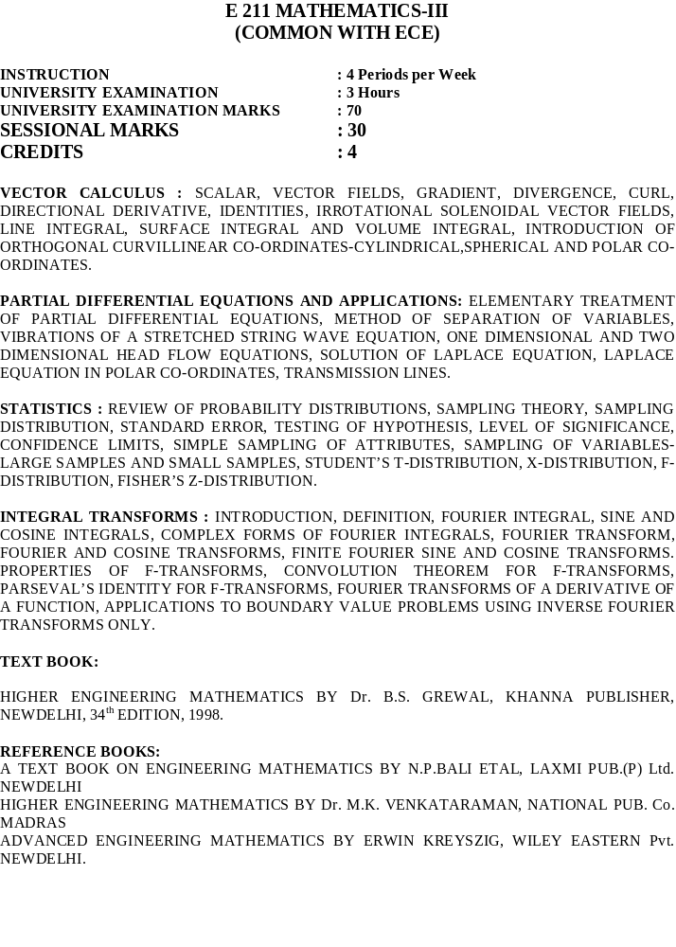

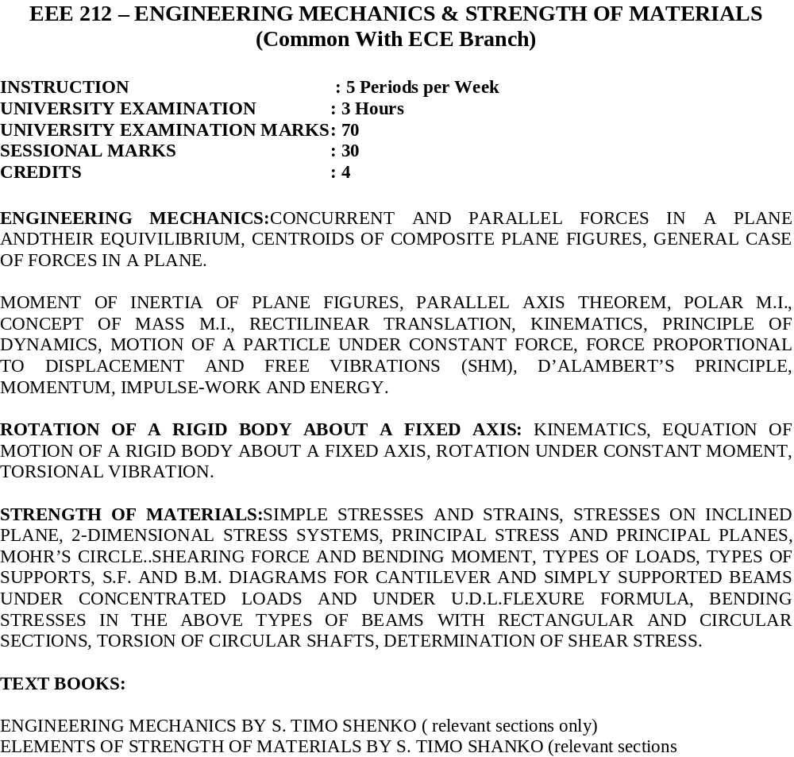

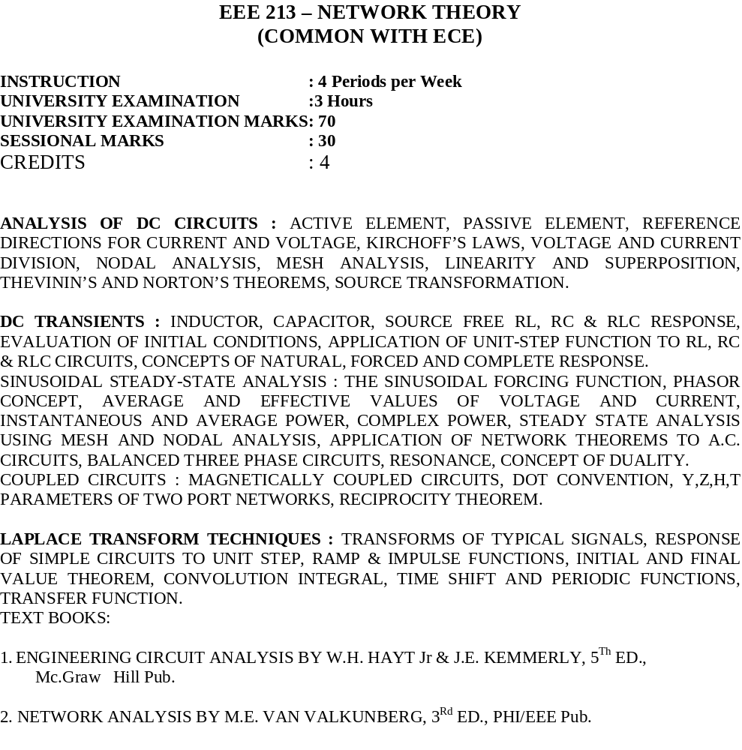

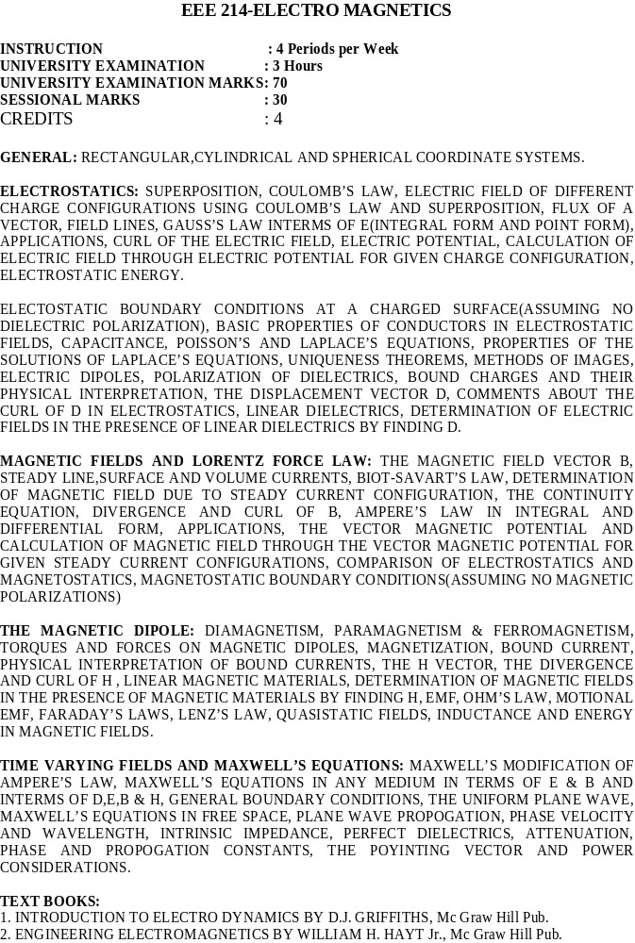

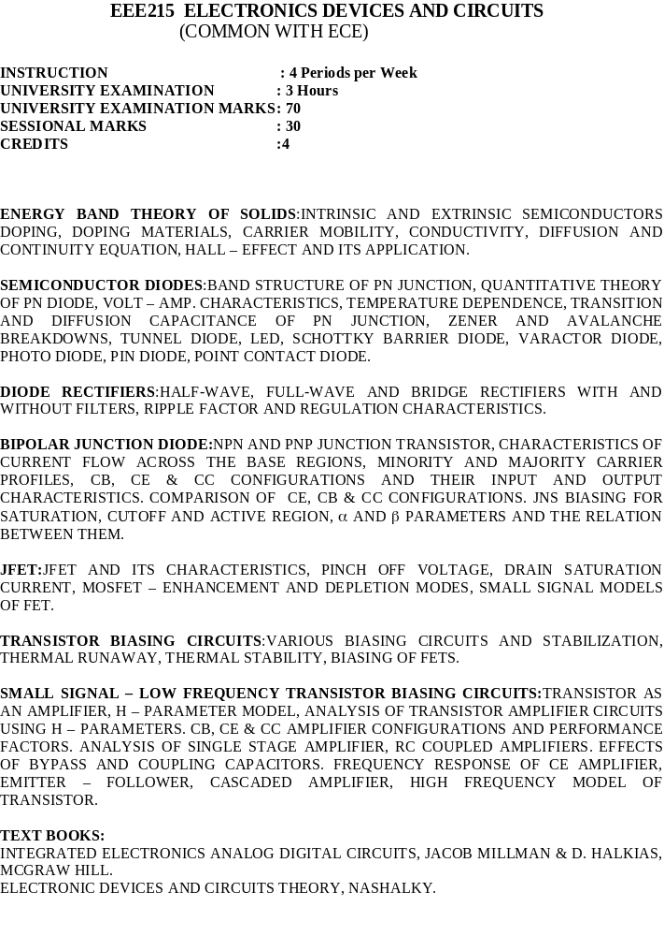

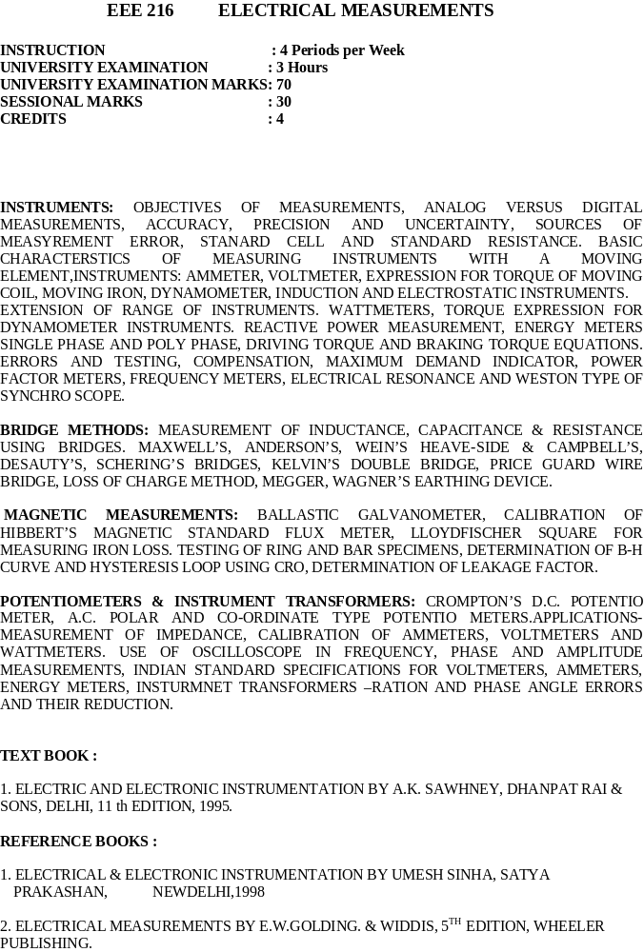

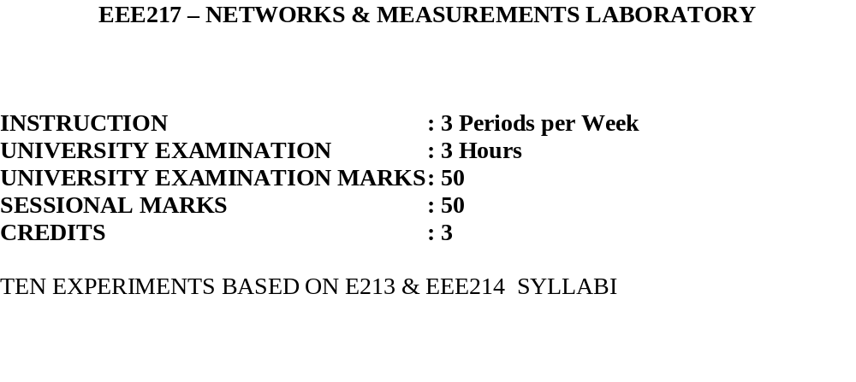
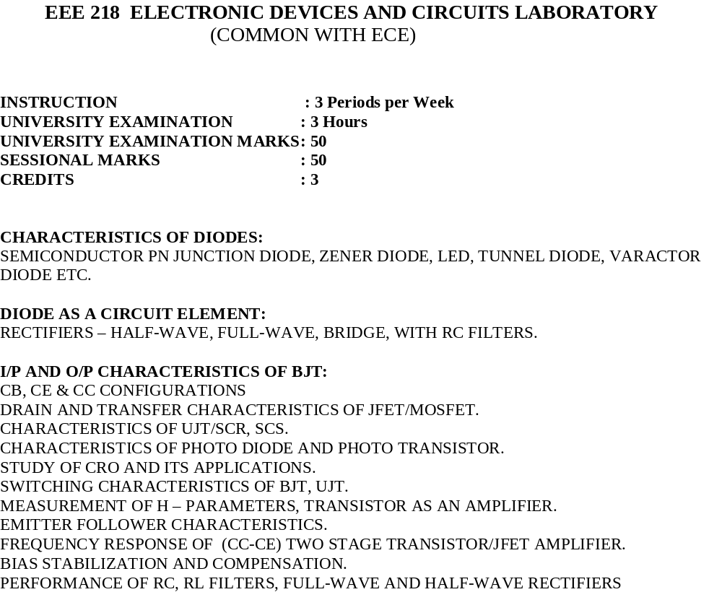

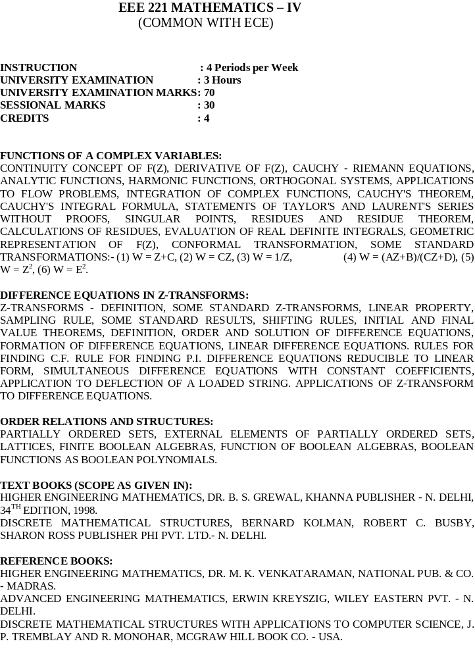

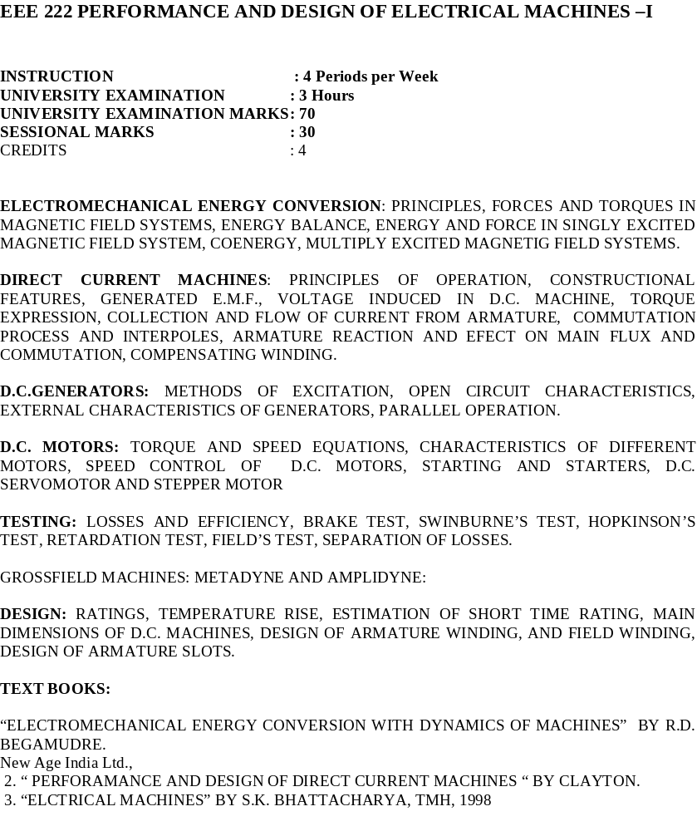

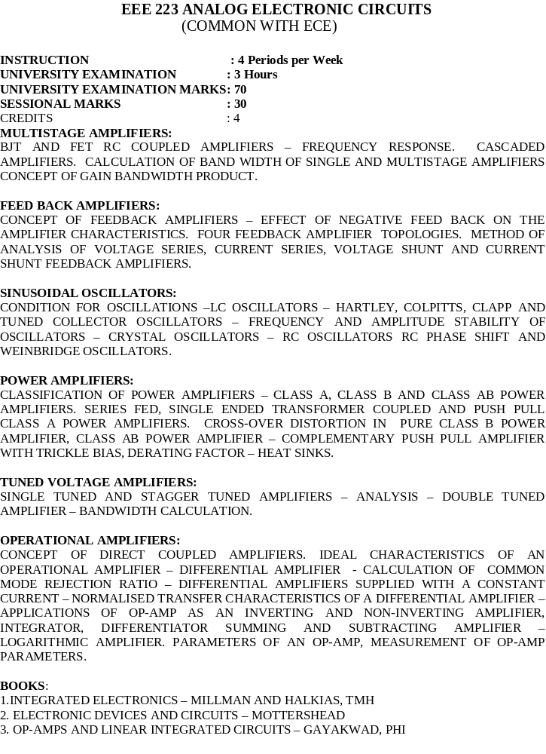

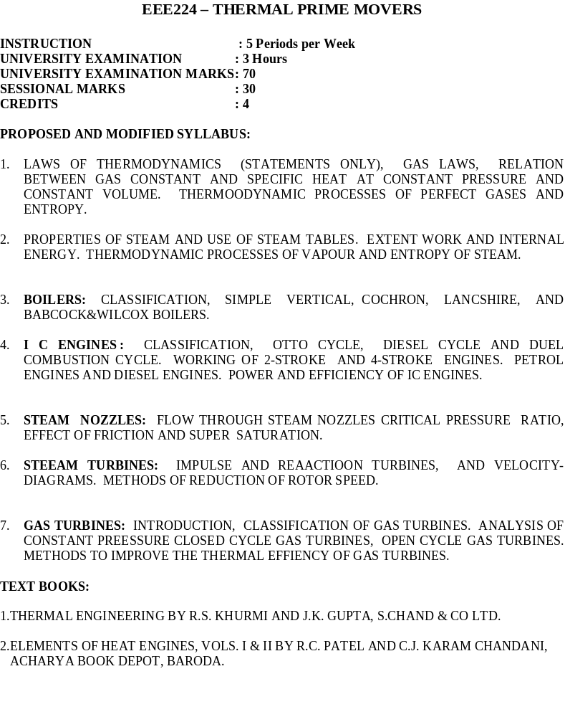

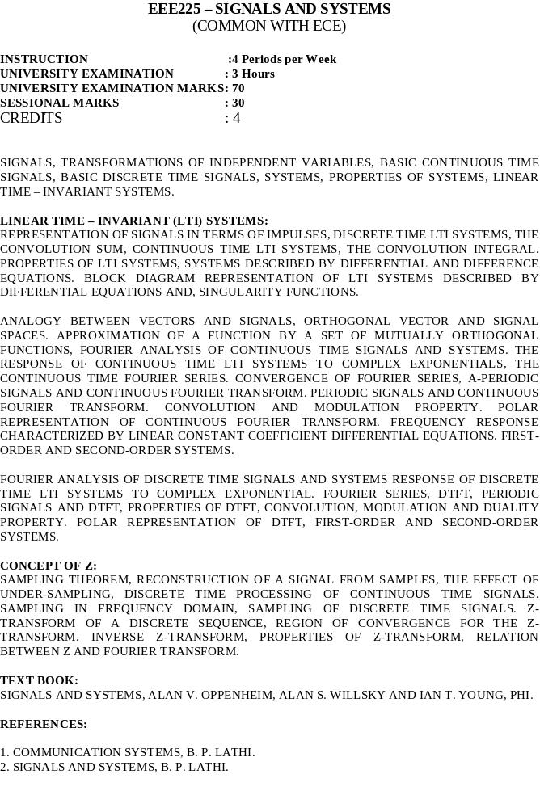



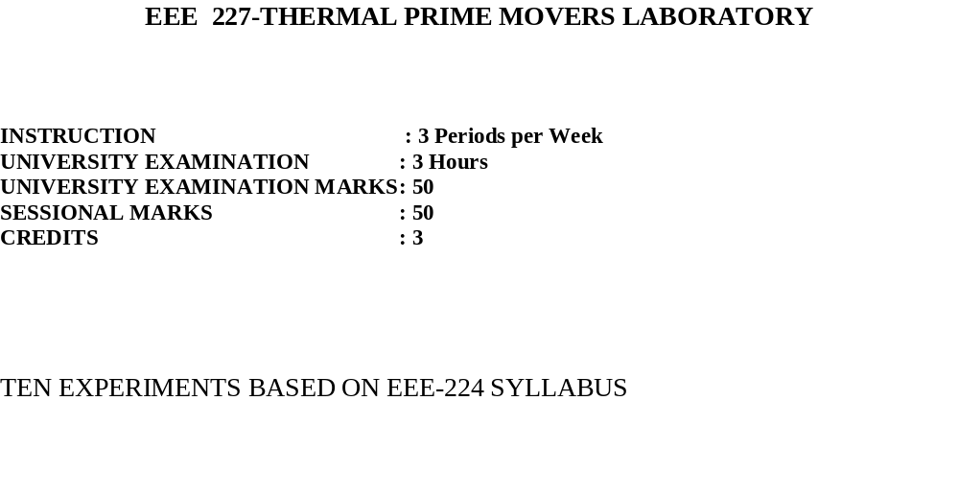

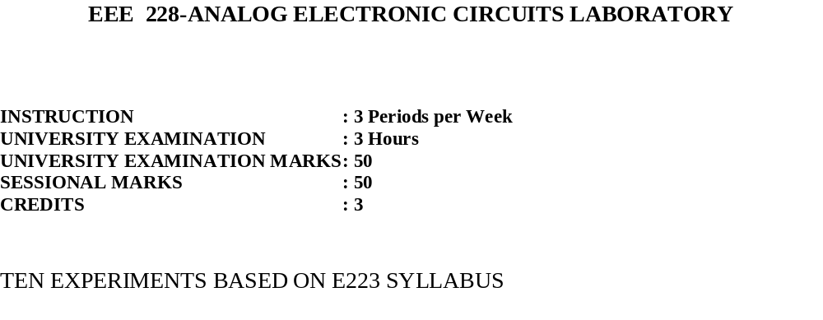

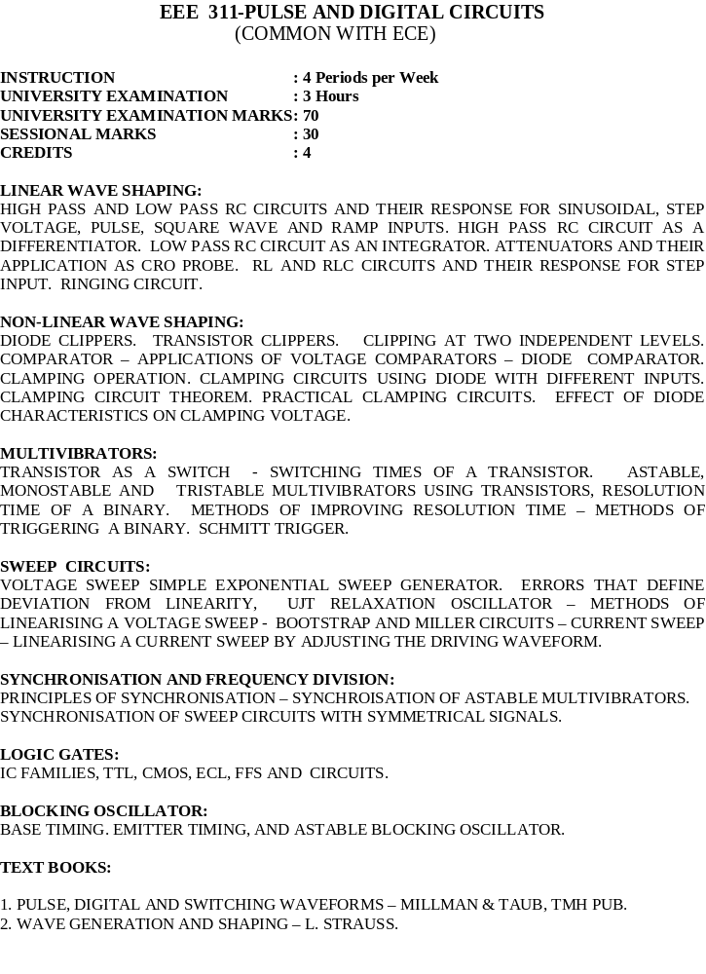

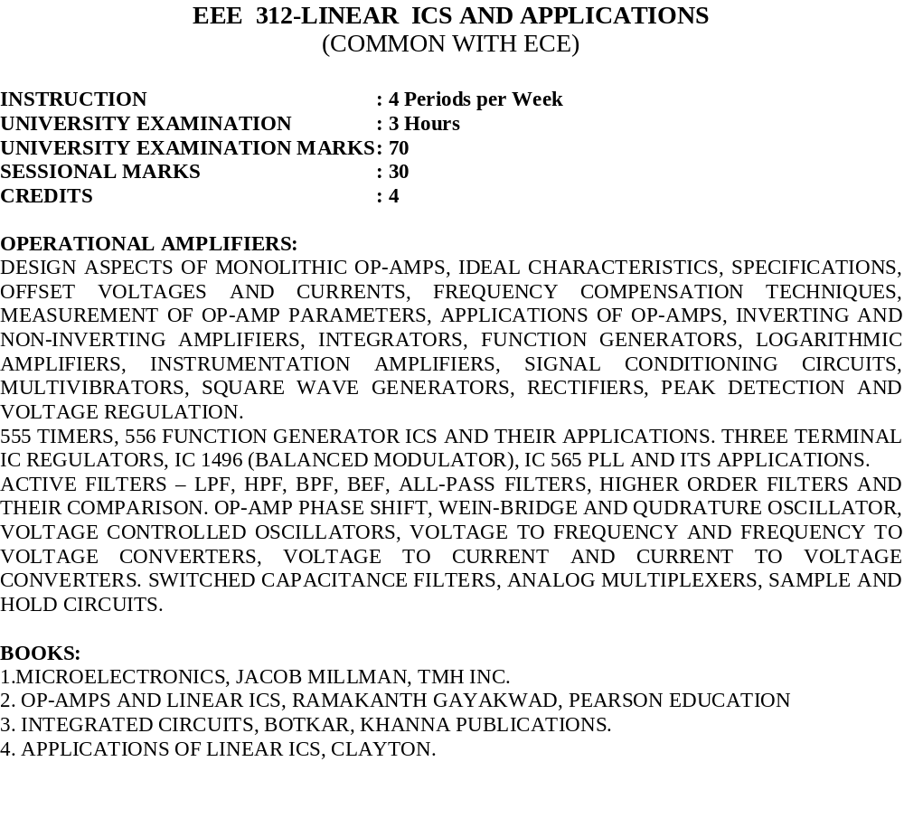

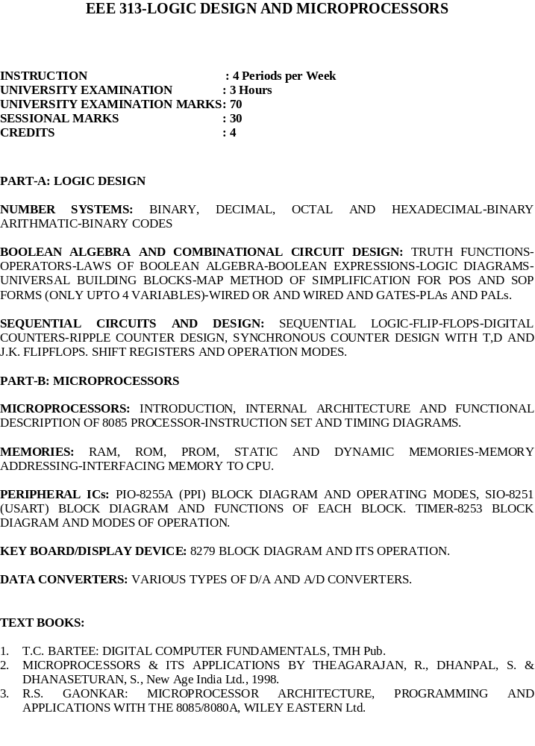

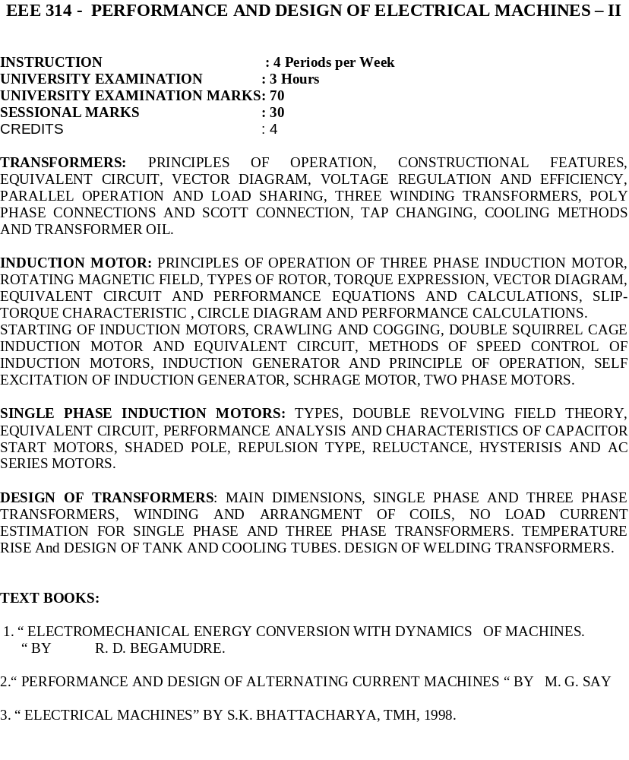

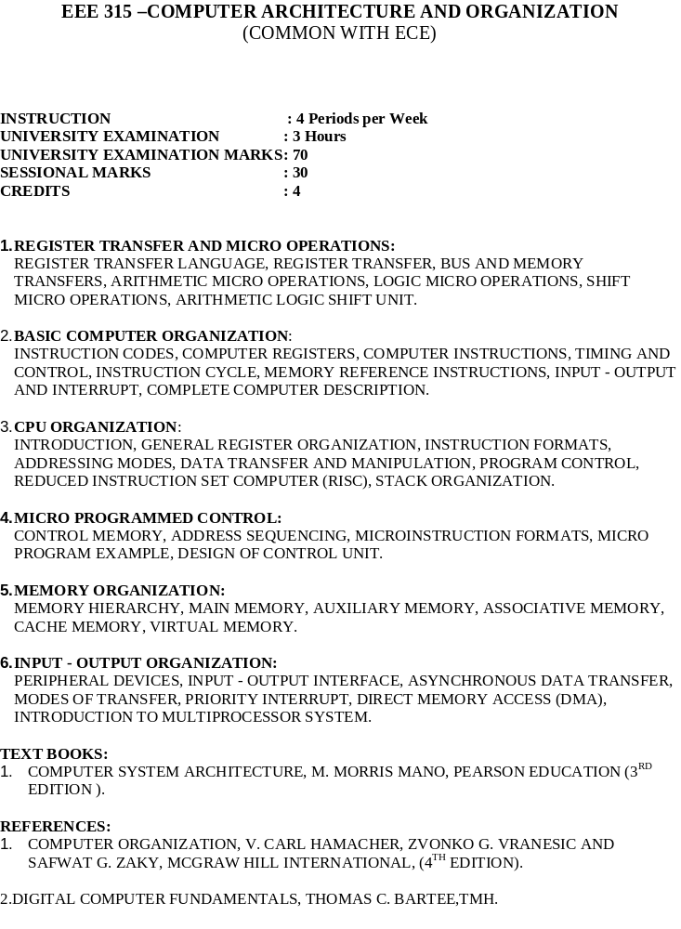

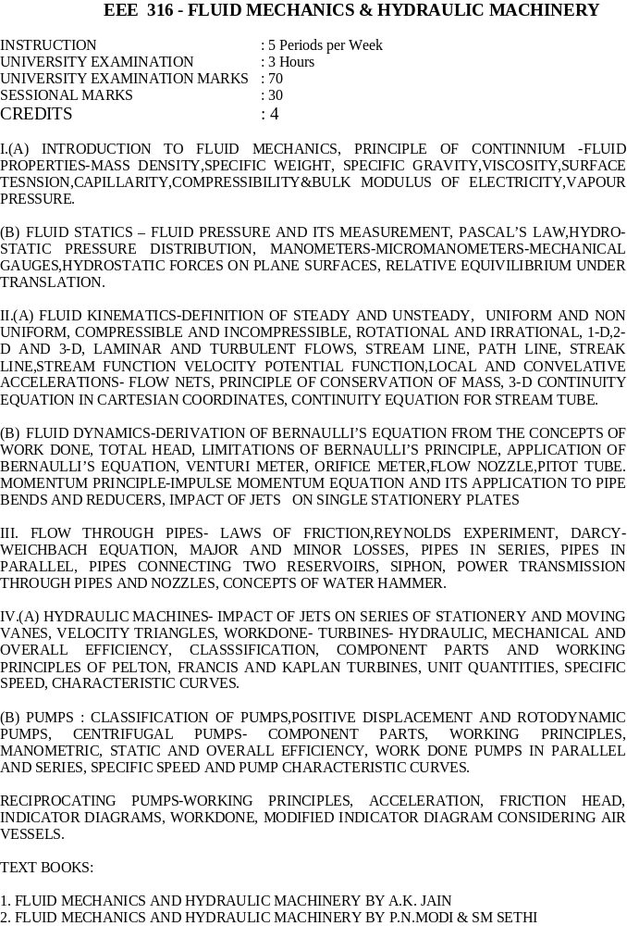

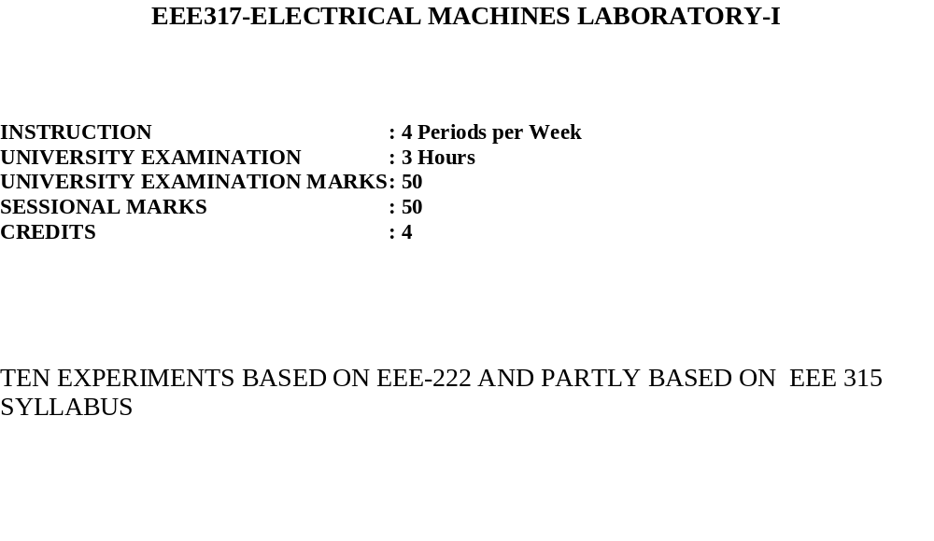
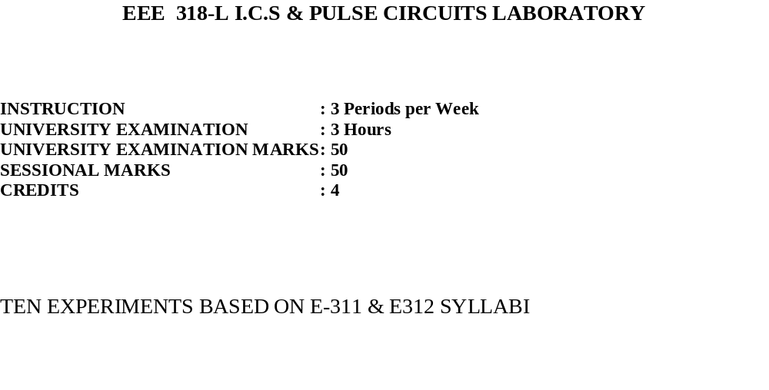
EEE 319- SOFT SKILLS LABORATORY

INSTRUCTION : 3 PERIODS PER WEEK
UNIVERSITY EXAM. : --
SESSIONAL MARKS : --
CREDITS : 1

(Common for all Branches of Engineering)

Communication:
Importance of communication
Non verbal communication
Personal appearance
Posture
Gestures
Facial expressions
Eye contact
Space distancing

Goal setting:
Immediate, short term, long term,
Smart goals, strategies to achieve goals

Time management:
Types of time
Identifying time wasters
Time management skills

Leadership and team management:
Qualities of a good leader
Leadership styles
Decision making
Problem solving
Negotiation skills

Group discussions:
Purpose (Intellectual ability, creativity, approach to a problem, solving, tolerance, qualities of a leader)
Group behaviour, Analysing performance

Job interviews:
Identifying job openings
Preparing resumes & CV
Covering letter
Interview (Opening, body-answer Q, close-ask Q),
Types of questions

Reference books:

1. ‘Effective Technical Communications’ by Rizvi M. Ashraf, McGraw–Hill Publication
2. ‘Developing Communication Skills’ by Mohan Krishna & Meera Banerji, Macmillan
3. ‘Creative English for Communication’ by N.Krishnaswami & T.Sriraman, Macmillan
4. ‘Professional Communication Skills’ by Jain Alok, Pravin S.R. Bhatia & A.M. Sheikh,
S.Chand & Co.



